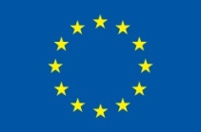
Project is funded
by the European Union

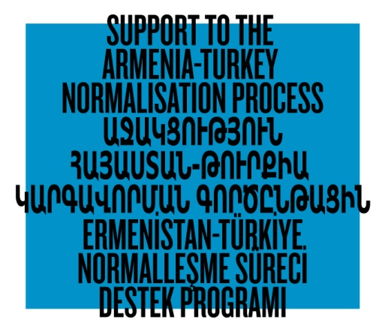

SUPPORT TO THE ARMENIA-TURKEY NORMALISATION
PROCESS: STAGE TWO

GRANT SCHEME

Grant Application Form

The Grant Scheme is developed by a Consortium of eight civil society organisations from Armenia and Turkey within the framework of the Programme Support to the Armenia-Turkey Normalisation Process: Stage Two, financed by the European Union under the Instrument contributing to Stability and Peace (IcSP).

The Programme aims to empower and engage civil societies of Turkey and Armenia to contribute to the enhanced regional peace and stability, democratic pluralism and social inclusion across and within their societies. This will be achieved through engaging new actors in economic, cultural, educational, and awareness-raising activities between Armenia and Turkey, and improving information flow, communication exchange and networking between media, expert communities and institutions.

- Project Title

- Project Location (country, city)

- Name of the Applicant

- Contact Details of the Applicant

  - Postal Address
  - Telephone Number
  - Name of the Contact Person in charge of the Proposed Project
  - Contact Person’s mobile phone
  - Contact Person’s e-mail
  - Head of the Organisation (if any)
  - Website of the Organisation (if any)

- Name and Contact Details of the Partner (Organisation/Individual) (if any)

- Project Goal and Objectives
Please mention how the proposed project contributes to the overall objective of the Programme Support to the Armenia-Turkey Normalisation Process: Stage Two (no more than 2 paragraphs)

- Project Duration (months, please indicate start and end dates)

- Total Budget of the Project (in Euro)

- Amount Requested from the Sub-grant Scheme (in Euro)

- Background and Justification
Describe the current situation, why the project is needed, and what the project seeks to achieve as a result (no more than 1 page)

- Target Group(s)
Describe and define the target groups and beneficiaries (also in number), how the project will address to their needs and constraints, how the project will ensure their participation (no more than 1 page)

- Project Activities
Provide an action plan (no more than 2 pages)

- Risks and Assumptions
Describe briefly possible risks associated with the implementation of your project and how they can be mitigated (no more than 1 paragraph).

- Partners and Complementarity
Describe the role of partners or networks, if any, involved in the project. If yes, indicate partner organisations and the country/countries of their operation. Briefly describe how your project complements the existing initiatives of local and/or international stakeholders who do similar projects (no more than 2 paragraphs).

- Expected Results and Impact
Describe the measurable outputs and qualitative outcomes you expect from the project (no more than 1 page).

- Project Sustainability
Describe the sustainability of the project’s expected outcomes (no more than 1 paragraph).

- Added Value and Innovation
What added value will the proposed project bring in addition to all of the similar work that is being done in the field? In short, what is innovative about your project idea? (no more than 1 paragraph).

- Has this project been submitted to other donor organisations for co-funding?
If yes, note which donor organisations are considering the proposal for which budget items and the date when the proposal was submitted. Please specify the amount of confirmed/guaranteed or pending co-funding and why additional co-funding is needed from the Sub-grant Scheme (no more than 1 paragraph).

- Relevant Experience and Capacity
Briefly describe the projects you or your organisation has implemented before in this particular field or similar areas. If your or your organisation’s field of specialty does not correspond with the qualifications required by the project, explain how and what kind of assistance/expertise you will get for the successful implementation of the project (no more than 2 paragraphs).

- Supporting Documents

- In case the applicant is an individual; please provide a copy of your passport

- In case the applicant is an organisation; please provide

- Official Name and Legal Status of the Applicant
Provide the name of your organisation as indicated in the charter of the organisation in Armenian/Turkish as well as the name in English.
Provide its legal status
- Certificate of Legal Registration (in native language)
- Charter of the Organisation (in native language)

- In case the proposed project will be implemented with Partner individuals or organisations, please provide

- The Name, Surname, Passport Copy and Contact Details of the Partner individuals

- Official Name and Legal Status of the Partner Organisation
Provide the name of the organisation as indicated in the charter of the organisation in Armenian/Turkish as well as the name in English.
Provide its legal status

- Signed Declaration by the Partner (see below)

DATE OF SUBMISSION:

SIGNATURE:

SEAL OF ORGANIZATION (if applicable):

Before submitting your application, please read the Guidelines for Grant Applicants to ATNP Sub-grant Scheme.

Armenia-based applicants should submit their application packages electronically to Eurasia Partnership Foundation (Armenia) at grants@epfound.am. Turkey-based applicants should submit their application packages to Hrant Dink Foundation (Turkey) at grants@hrantdink.org

Armenia-based applicants can address their inquiries to Mr. Artak Ayunts at +374 10 25 15 75 (ext. 118) or aayunts@epfound.am

Turkey-based applicants can address their inquiries to Ms. Nazlı Türker at +90 212 240 33 61 or nazliturker@hrantdink.org

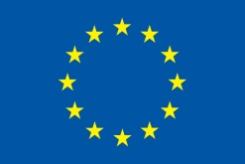

Support to the Armenia-Turkey Normalisation Process is funded by the European Union

DECLARATION BY THE PARTNER

The partner <indicate the name of the individual or organisation> authorises the Applicant <indicate the name of the individual or organisation> to submit on their behalf the present Application for the Sub-grant Scheme within the framework of the Programme Support to the Armenia-Turkey Normalisation Process: Stage Two, and to sign the grant contract with the Eurasia Partnership Foundation as well as, to be represented by the Applicant in all matters concerning this grant contract.

I have read and approved the contents of the proposal submitted to the ATNP Consortium.

I undertake to comply with the principles of good partnership practice.

Name:
Organisation:
Position:
Signature:
Date and place:

