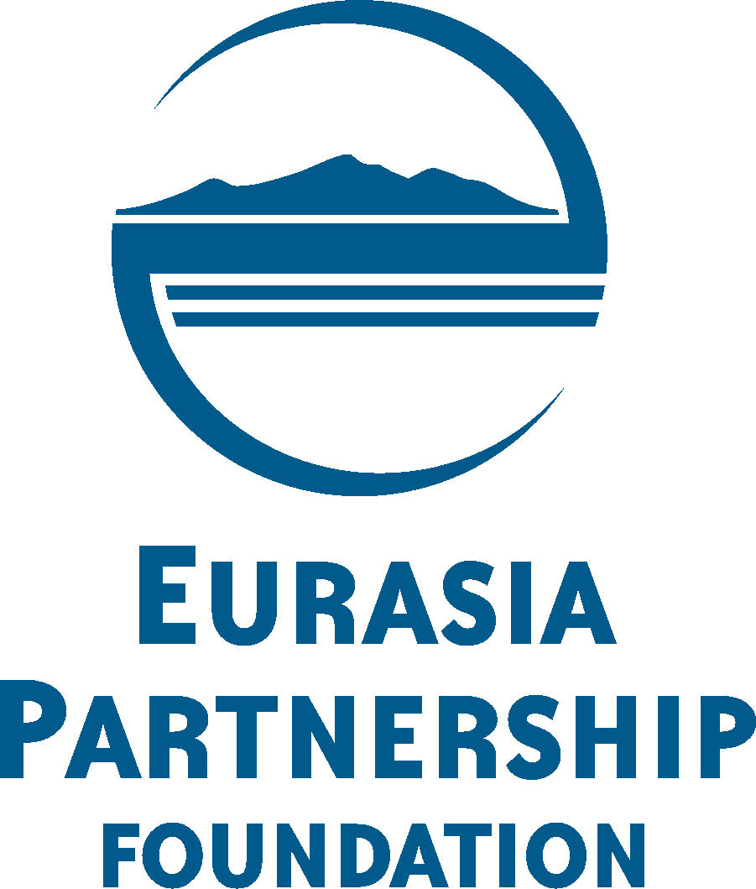 | 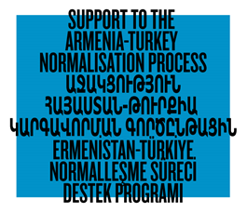 | 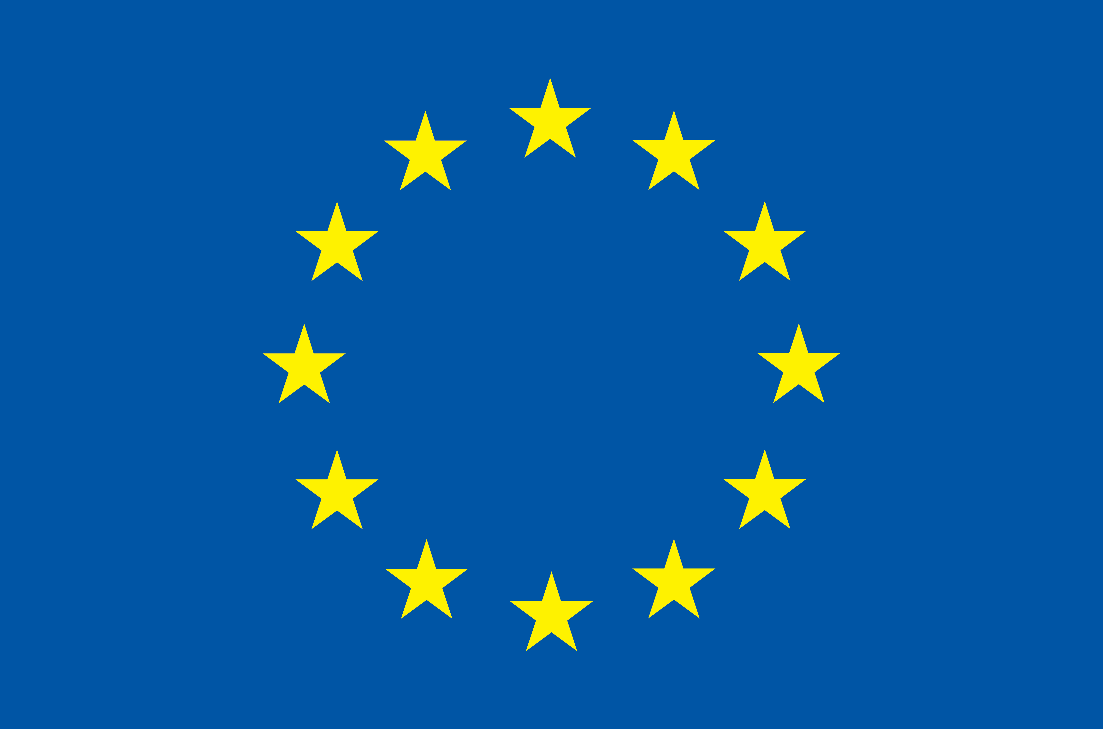  Programme funded by the  European Union

Application Form for Media Bus Tour in Turkey and Armenia for Journalists and Bloggers from Turkey and Armenia

Name, Surname ________________________________

Date of Birth ________________________________

Telephone (work) ________________________________

Telephone (mobile) ________________________________

E-mail ___________________________________

Work Experience
NN | Company/Organisation/Media | Years | Position

Languages

- Armenian
- English
- Turkish
- Other

Articles/reports covering Armenia-Turkey relations

NN | Title, Type/article, video material, etc./ | Name of Media | Date of publication

How did you learn about the Media Bus Tour opportunity?

- Mailing list
- EPF’s web-site
- Programme’s web-site
- Friends/Colleagues
- Other

We will very much appreciate if you could briefly answer to the following two questions. Please note that this section is not mandatory, and you can omit it.

- What is your motivation to participate in the Media Bus?
________________________________________________________________________________________________________________________________________________________________________________
- What are your expectations from the Media Bus Tour?
________________________________________________________________________________________________________________________________________________________________________________

Media Bus Tour takes place within the framework of the programme 'Support to the Armenia-Turkey Normalisation Process funded by the European Union
www.armenia-turkey.net

