RESS RELEASE Contact person
Ester Hakobyan
For immediate release Cell: +37498 540 804
E-mail: estherhakobyan@pjc.am

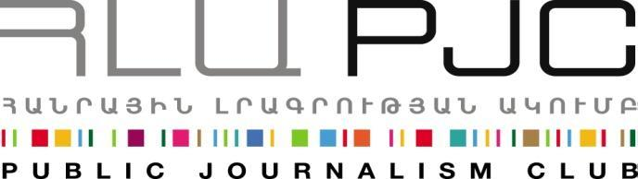
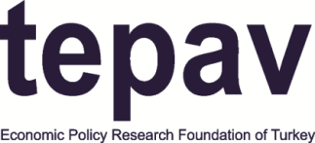

Getting to Know Information and Communication Technology (ICT) Sectors in Armenia and Turkey

07 November 2014, Yerevan

A round table discussion titled “Getting to Know Information and Communication Technology (ICT) sector in Armenia and Turkey: Exploring Collaboration Opportunities” was held on November 6, at 16:00 at the VIP auditorium of Elite Plaza Business Hotel (Yerevan, Khorenatsi 15). The round table kicked off the “Exchange of Entrepreneurs” Project jointly organised by the Public Journalism Club and the Economic Policy Research Foundation of Turkey (TEPAV) within the framework of the programme ‘‘Support to the Armenia-Turkey Normalisation Process’’ funded by the European Union. The project aims to help ICT representatives from Turkey to form an understanding of the ICT sector in Armenia and explore opportunities for collaboration.
The round table discussion hosted over 60 participants including established entrepreneurs and investors, ICT experts and top executives from Armenia, Turkey and the U.S. as well as startup entrepreneurs.
Seda Muradyan, president of the Public Journalism Club (Armenia) and Ussal Şahbaz, representative of the Economic Policy Research Foundation of Turkey (TEPAV) opened the event as the representatives of implementing organisations.
Seda Muradyan said "This is first large scale industry to industry exchange project, and we are hoping that it will create a foundation for future collaboration prospects. We are trying to build "human pipeline" between these spheres, and to activate interest among neighbours towards entrepreneurial ecosystems, which can lead to better regional integration".
Ussal Şahbaz noted "Technology entrepreneurs in any part of the world speak the same language. They try, fail, and try again. Our delegation is a first trial to open a new venue in people-to-people exchanges between Armenia and Turkey. We are proud to bring the largest technology entrepreneurship delegation from Turkey ever to Armenia. We expect this visit to pave the way for new collaborations to create more jobs and increase the mutual understanding on both sides of the border".
The Head of the European Union Delegation to Armenia, Ambassador Traian Hristea and the U.S. Ambassador to Armenia John Heffern delivered welcoming remarks.
Ambassador Traian Hristea emphasized the support of the EU for civil society initiatives contributing to dialogue and contacts for the normalisation of relations between Armenia and Turkey. "This exchange is novel in bringing together entrepreneurs, investors, executives and start-ups representing new technologies in both countries and the first opportunity for such industry to industry exchange," he noted.

Ambassador John Heffern emphasized the fact that the initiative was a joint one between Armenia and Turkey and that it is supported both by the European Union and the U.S. Embassy. He said he hoped the participants can become the living prove of the reality that there are more similarities than differences. between the two countries and cultures
The round table discussion featured two panels. The first one focused on ICT industry in Armenia and state support to the sector, while the second one looked into new technologies as an opportunity and related issues of education, social entrepreneurship and others.
The panellists included Karen Vardanyan, head of Union of IT Enterprises (UITE), Bagrat Yengibaryan, director of the Enterprise Incubator Foundation (EIF), Manuk Hergnyan, managing partner of Granatus Ventures, Yeva Hyusyan, head of Microsoft Armenia, Nazareth Seferyan, a Corporate Social Responsibility Expert, Marina Mkhitaryan head of UNDP’s innovative Colba Lab, Serob Khacatryan, a professor of Philosophy at the Yerevan State University and an education expert and Artashes Vardanyan, head of Microsoft Innovation Centre’s acceleration program.
Representative of the delegation from Turkey Numan Numan, Director at 212 and Erhan Erkut, Vice-Rector and Dean at MEF University also spoke at the discussion.
Exchange of Entrepreneurs
The "Exchange of Entrepreneurs" project aims to enable successful interaction between entrepreneurs involved in Information and Communication Technologies (ICT), developers, designers, marketers, product managers and start-up enthusiasts from Armenia and Turkey and create new opportunities for cooperation amongst them.
The highlight of the exchange is the Armenia-Turkey Startup Weekend, which will kick off on November 7 in Yerevan (from 17:00 to 20:00 at the Green Show Room of Elite Plaza Business Centre) and continue on November 8-9 at Gyumri’s TechnoPark (Gyumri, Guy 1).
The project includes a series of activities such as exchange visits, business meetings and roundtable discussions for entrepreneurs to be held in Armenia and Turkey alongside with a Startup Weekend. The activities will be focused on ICT entrepreneurial eco-systems of both countries. Delegations from both countries will visit leading ICT innovation centers and engineering laboratories, and will meet leaders in the ICT spheres. The first stage of the project will be held in Armenia, on November 6-9, 2014.
The second stage of the Exchange of Entrepreneurs Project will take place in Istanbul in December 2014.
For inquires on project details please contact Ester Hakobyan at estherhakobyan@pjc.am and +374 98 540 804. (Public Journalism Club, info@pjc.am, + 37460 505 898)

***

Support to the Armenia-Turkey Normalisation Process is a Programme implemented by a Consortium of eight civil society organisations from both countries with the financial assistance of the European Union under the Instrument for Stability.

The overall objective of the Programme is to promote civil society efforts towards the normalisation of relations between Turkey and Armenia and towards an open border by enhancing people-to-people contacts, expanding economic and business links, promoting cultural and educational activities and facilitating access to balanced information in both societies.

The Consortium partners include Civilitas Foundation (CF), Eurasia Partnership Foundation (EPF), Public Journalism Club (PJC), Regional Studies Center (RSC) from Armenia; and Anadolu Kültür, the Economic Policy Research Foundation of Turkey (TEPAV), Helsinki Citizens’ Assembly (hCa), and Hrant Dink Foundation from Turkey.

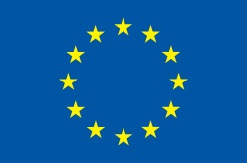

Support to the Armenia-Turkey Normalisation Process is funded by the European Union
www.armenia-turkey.net

