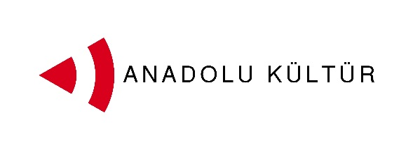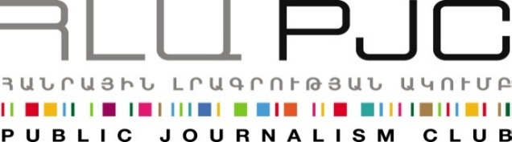
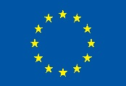
European Union

Press Release

The Participants of the “Exchange of Painters” Project Visit Garni Temple and Geghard Monastery

Yerevan, 03.09.2014 : On September 3rd the groups of painters from Turkey and Armenia visited the Garni temple and Geghard Monastery under the framework of the Exchange of Painters project . The trip was intended to help the participants familiarize with historical and cultural value of these two major monuments, their history, architecture as well as the surrounding landscape.
The trip to Garni and Geghard included one of the five open air studios planned within the framework of the program. The participants were able to sketch around these two historical and cultural sites reflecting their impressions via the means of painting.

Culture is one of the possible tracks for promoting dialogue between the societies of Armenia and Turkey. More specifically, artistic activity can help an effective interchange since it does not need translation and mediation, and it transmits messages fineand creates bonds using the universal language of art. With this in mind the Public Journalism Club, in partnership with Anadolu Kültür, has launched the “Exchange of Painters” project focusing on the role of art in promoting Armenia-Turkey relations.
The project was launched on September 1 and its activities will continue through September 7.

For inquires on project details please contact Ester Hakobyan at estherhakobyan@pjc.am and 098540804:
Public Journalism Club. mailto: info@pjc.am or call + 37460 505 898.

***
Support to the Armenia-Turkey Normalisation Process is a Programme implemented by a Consortium of eight civil society organisations from both countries with the financial assistance of the European Union under the Instrument for Stability.

The overall objective of the Programme is to promote civil society efforts towards the normalisation of relations between Turkey and Armenia and towards an open border by enhancing people-to-people contacts, expanding economic and business links, promoting cultural and educational activities and facilitating access to balanced information in both societies.

The Consortium partners include Civilitas Foundation (CF), Eurasia Partnership Foundation (EPF), Public Journalism Club (PJC), Regional Studies Center (RSC) from Armenia; and Anadolu Kültür, the Economic Policy Research Foundation of Turkey (TEPAV), Helsinki Citizens’ Assembly (hCa), and Hrant Dink Foundation from Turkey.
For further details on the programme and the project, please visit www.armenia-turkey.net

